Team C--

Vicki Ponarski, Grant Metts, Felix Lu, Kangwoo Choo, William Moreno, Zhonglin Cao

User Guide

Due: 11:59pm December 2, 2018

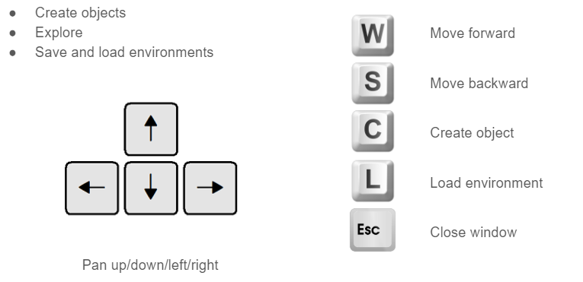

* Options for creating objects:
  + sphere
  + triangular prism
  + rectangular prism